September 23, 2018

Ana Slocum - S00615504

IT2320 Lab 3

CRN 82936

# Screenshots

No Moves Yet

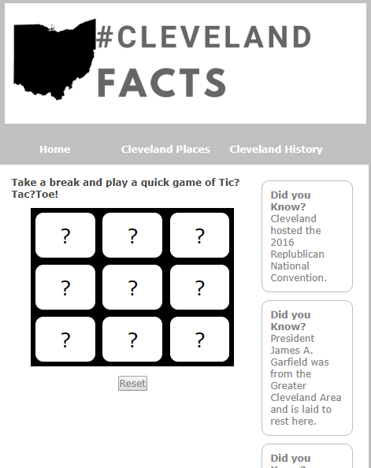

First Move

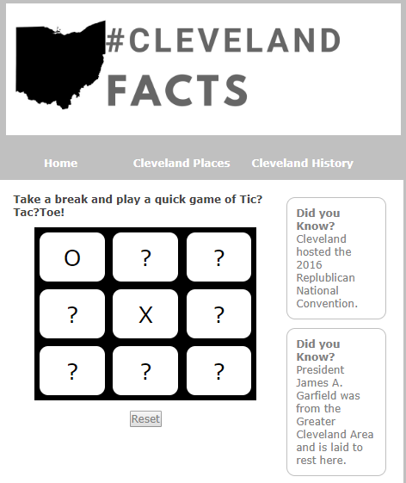

Draw

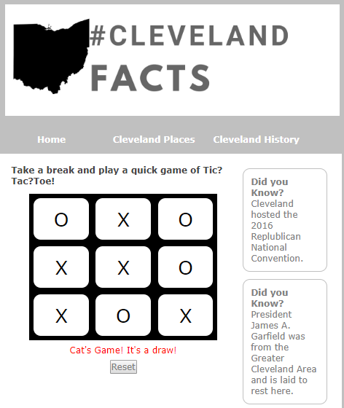

Winner

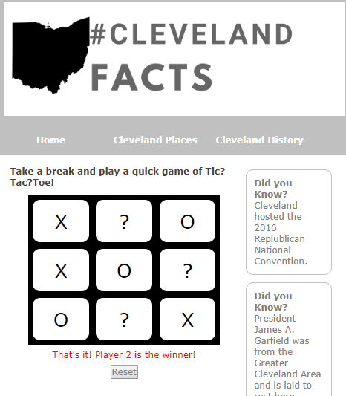

Reset

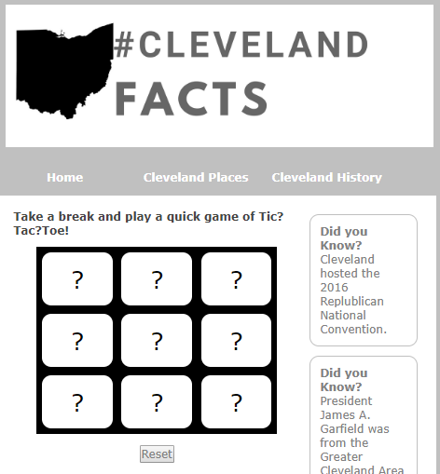

# GitHUB Commit ID

33978ec

33978ec70238d682161eeeae5b121b52fcd6241a

# Notes

I wasn’t sure if we needed to submit a Word doc or not – so here it is.

I also wasn’t sure if it should be within the website we made previously. I erred on the side of caution and did it within the site made previously. I did not add any links to it elsewhere. The html file is in the “game” folder, the css file is in the “styles” folder, and the js is in the “scripts” folder.